# Chapter 4

**ANALYSIS AND DESIGN OF THE SYSTEM**

System analysis is a [problem-solving](https://en.wikipedia.org/wiki/Problem-solving) technique that breaks down a system into its component pieces for the purpose of the studying how well those component parts work and interact to accomplish their purpose.

# Analysis of the system

The Web Store System has a scope of three levels.

* + - The User Login.
    - The Home Page.
    - The Checkout Page

# Design of the system

Systems design is the process of defining the [architecture,](https://en.wikipedia.org/wiki/Systems_architecture) modules, interfaces, and [data](https://en.wikipedia.org/wiki/Data) for a [system](https://en.wikipedia.org/wiki/System) to satisfy specified [requirements](https://en.wikipedia.org/wiki/Requirement). It is the application of [systems theory](https://en.wikipedia.org/wiki/Systems_theory) to [product](https://en.wikipedia.org/wiki/Product_development) [development.](https://en.wikipedia.org/wiki/Product_development) There is some overlap with [system analysis,](https://en.wikipedia.org/wiki/Systems_analysis) [system architecture](https://en.wikipedia.org/wiki/Systems_architecture) and [system](https://en.wikipedia.org/wiki/Systems_engineering) [engineering.](https://en.wikipedia.org/wiki/Systems_engineering)

**4.2.1 Architecture of the system**

A use case diagram at its simplest is a representation of a user's interaction with the system that shows the relationship between the user and the different use cases in which the user is involved. A use case diagram can identify the different types of users of a system and the different use cases and will often be accompanied by other types of diagrams as well. The use cases are represented by either circles or ellipses.

A use case diagram is the perfect way to representing how the system works in action in a real world scenario. The interaction between user and the website is represented in the use case diagram. Web Customer actor uses some web site to make purchases online. Top level use cases are View Items, Make Purchase and Client Register. View Items use case could be used by customer as top level use case if customer only wants to find and see some products. This use case could also be used as a part of Make Purchase use case. Client Register use case allows customer to register on the web site, for example to get some coupons or be invited to private sales.

Figure 4.1 shows the Use-Case diagram for Web Store System. It illustrates the interaction between user and the website. Users can view the items available and add items to cart with a single click. Users can also buy the items by entering their card details.

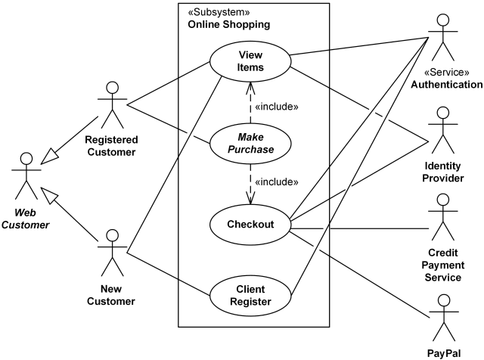

Figure 4.1 Use-case Diagram for Web Store System

The website provides the option of either logging in for existing users or signing up for new users. After successful login/registration, the user is directed to the home page where the user can select from various products and add them to cart. The user can then checkout and verify the contents of the cart and proceed to make the payment.